Chapter 12, Solution 81.

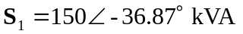

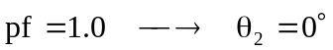
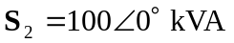

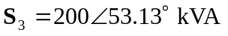

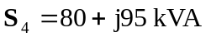

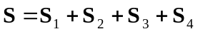

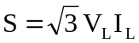

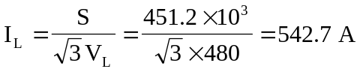

For the line,
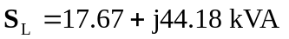

At the source,
